1/1

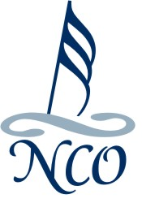
Nanaimo Chamber Orchestra
Concerto Competition 2018 Rules

For Young Instrumentalists and Singers

Applicants must:
- Be 13-21 years of age as of January 1st, 2018
- Specify a desired concerto or concert piece for solo/duo string, wind or brass instrument, solo piano or solo/duo voice. ACCOMPANIED BY STRING ORCHESTRA ONLY. Any entries requiring additional instruments will not be considered.
- Reside in the central Vancouver Island area
- Provide own accompanist for audition
- Must demonstrate a performance level at or above ROYAL CONSERVATORY GRADE 7

Applications:
- 1st STAGE- Applicants’ music choice only. Due by November 30th, 2017 or earlier, via email to lakrull1@gmail.com Give yourself time to choose another piece should your first choice be declined.
- 2nd STAGE- Upon approval of 1st stage the full application form is due by February 16th, 2018.

Auditions
- Successful Applicants will be contacted after February 16th, 2018 to arrange audition times
- Auditions will occur on February 25th, 2018
- The selected soloist must be available for Wednesday evening rehearsals and for the performance dates of June 2nd and June 3rd, 2018

Any person who has won the Competition is ineligible to compete for the following year.

Application forms available at:
www.nanaimochamberorchestra.com
Nanaimo Conservatory of Music

For more information or clarity of rules please contact:

Leslie Krull
(250) 758-3317
lakrull1@gmail.com

